**Jenkin’s**

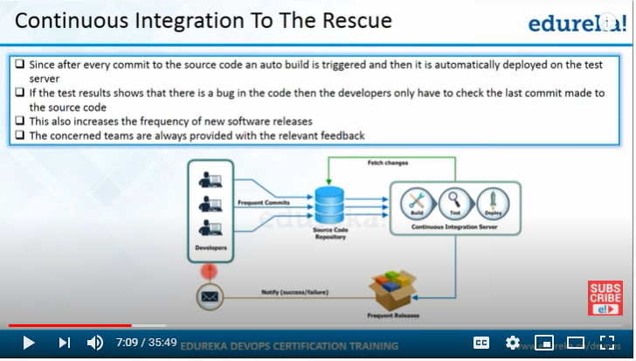

As per the above diagram whenever a developer commit code into Repository(Git) It will Build,Test and Deployed on Test Server

At the same time Developers will get continuous feedback about Build and Test results

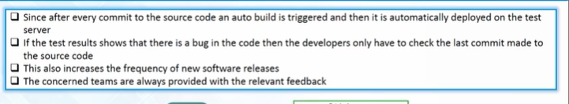

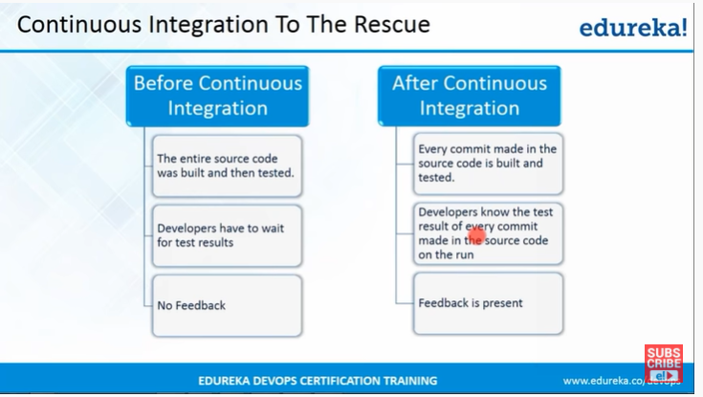

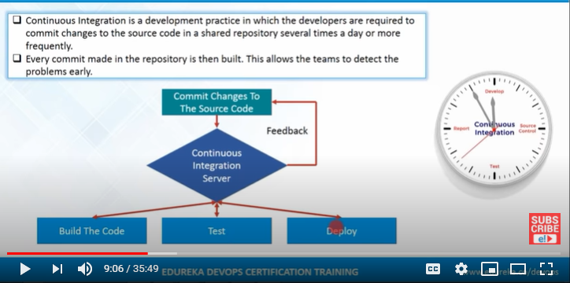

Before continuous Integration complete source code will compile and prepared a build if we found any bugs then complete code have to check to fix it , its very difficult in this process

To overcome this CI is implemented in CI process whenever Source code is committed Integration Server(Jenkins,Teamcity…) will compile and prepare build for every commit ,and deployed it and then Testing will happen

Each any every action will send email notification to Developers

So if they face any error on any commit they will validate it and will fix it , so its easy for them to fix

Only that committed source code will validate by them

**Continuous Integration Tools**

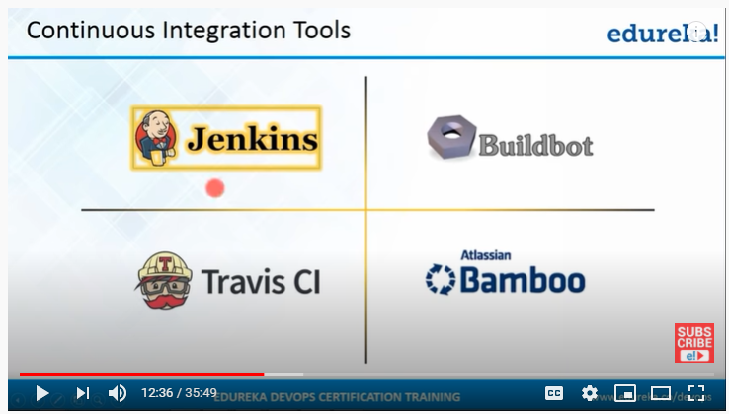

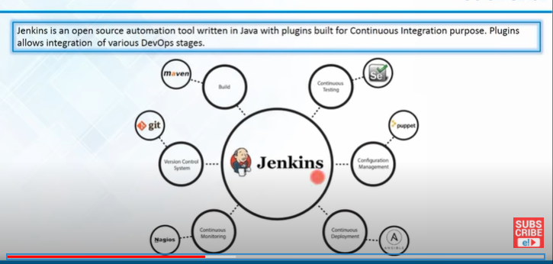

**Jenkins is the most popular tool because we have 1000+ plugin’s available for it**

As per the above diagram we have plugin for all process (Repository(Git), Build(Maven), Testing(selenium) , Continuous Mgmt(puppet), continuous deployment (Ansbile)

If we want to Integrate any tool with Jenkins then that Tool plugin should be installed in Jenkins

**Jenkins Dashboard**

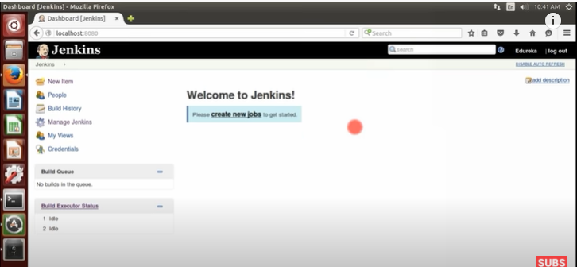

Dashboard is Empty, if you want to add any new project click on New Item

While Installing Jenkins we will get some popular Plugins and at the same time we will have option that we can install any plugin at any time which we required

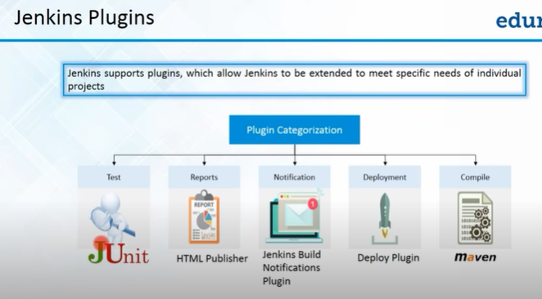

**Installation of Plugin**

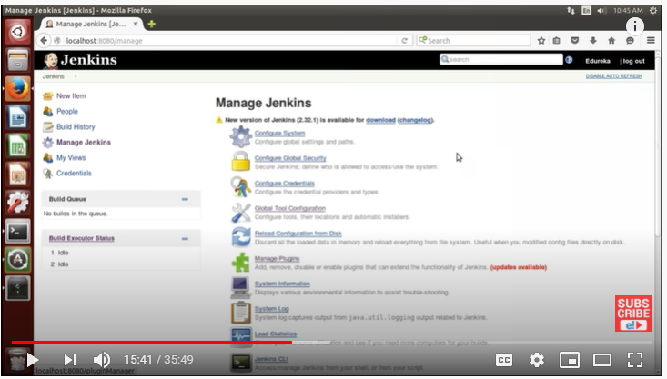

If we want to Install any plugin click on Manage Jenkins>Manage Plugin>

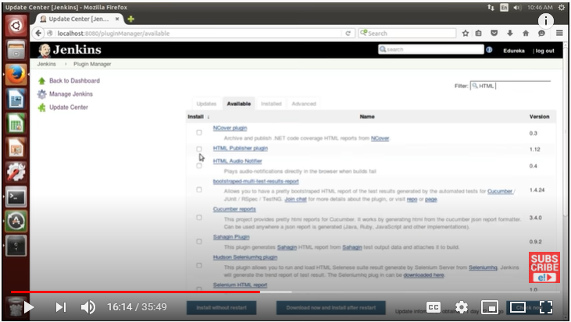

If we see above window we can see all the Installed plugins and we can see all the Available plugins

We can install our required plugin by selecting it

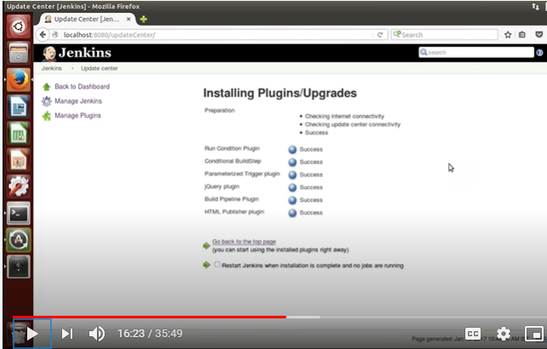

**Creation of New Project**

**Click on New Item from dashboard**



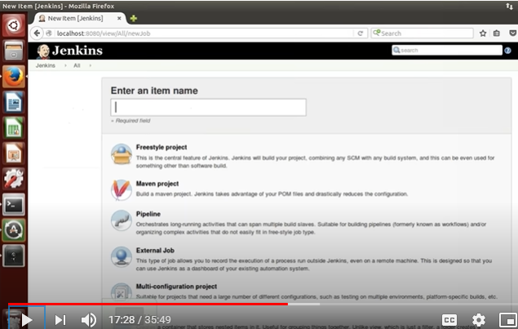

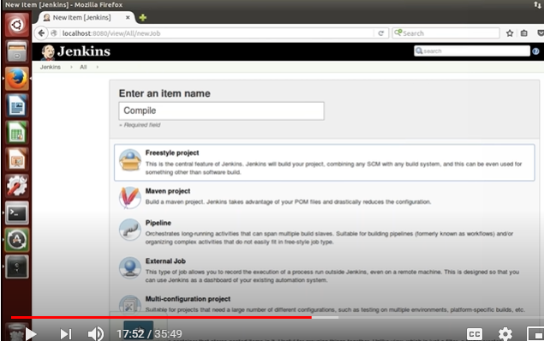

By following above process we will create New project

We will select Freestyle Project, because the configuration of it is good

We have to provide all the below details to complete it

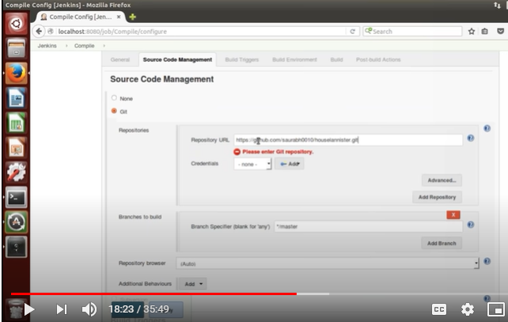

In source code Managnment configuration we have to select the Respository (Git), here we have selected Git repository

And we have to provide the repository url (path)

Once we provided Repository URl then we have to provide below Build details

We have to select Build Method(Build Methods like Maven, Ant, CARA…etc ) so every build methods have it own process lifecycle like ( Validate it, Compile it, Test It, Build IT and Deploy IT)

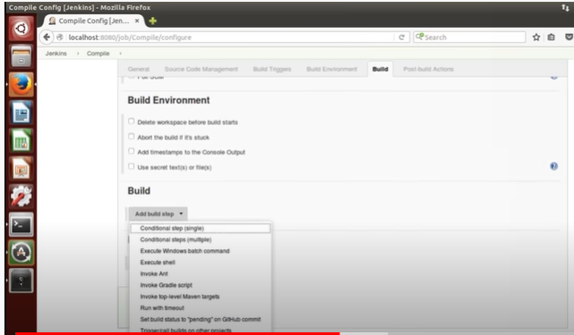

As per the above we have selected Build step is Maven

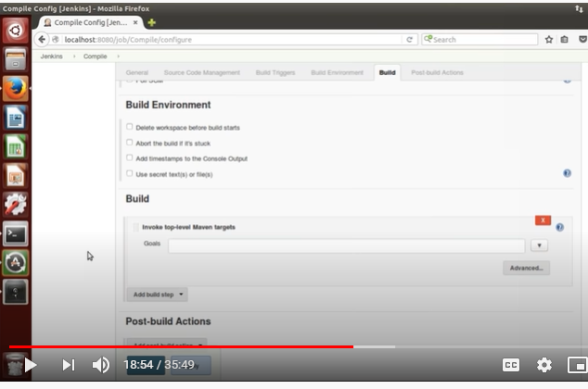

Once we selected the Build step we have to provide Goal (means that what action we required) here we have selected Compile action like below

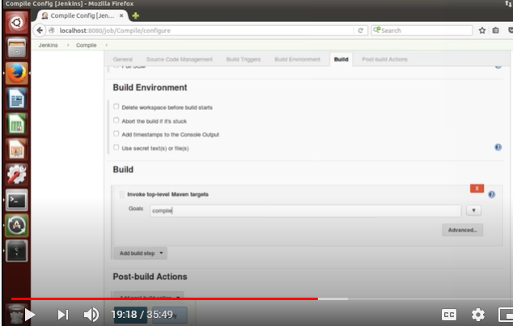

Apply it and save it

Once above configuration is completed we can run the Build by clicking Run build option

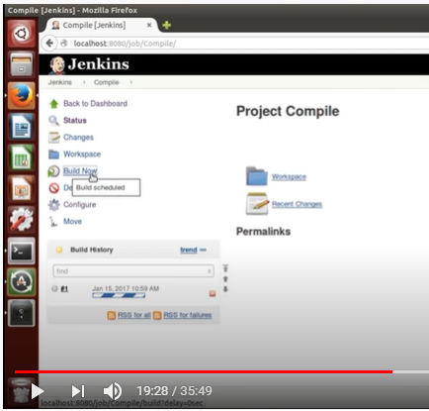

Now compilation is done

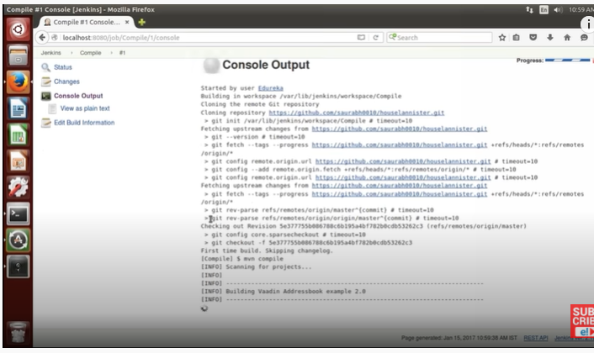

If we see Jenkins dashboard our compile project is available like below

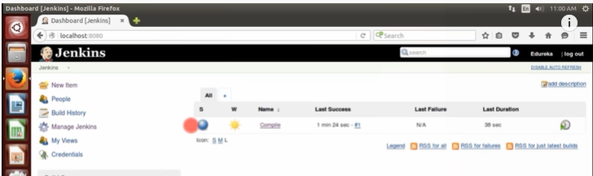

By following above process we have compile the code and created the Build as shown in below diagram

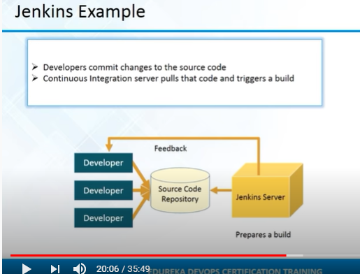

Now build is ready we have to deploy it and have to move to Testing face

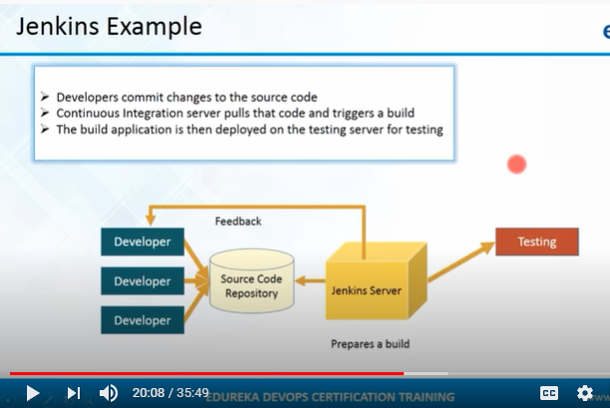

Before Deployment and Testing we have to Review the code by following below process

To review any code we will use pmd plugin

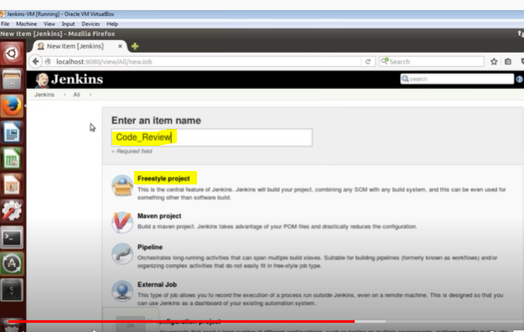

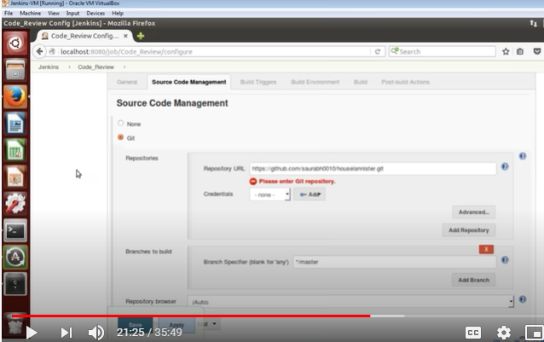

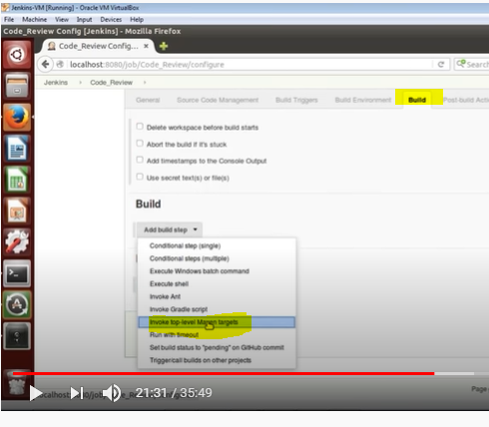

To review the code we will use metrics profile(-p pmd:pmd) by selecting publish PMD analysis result like below

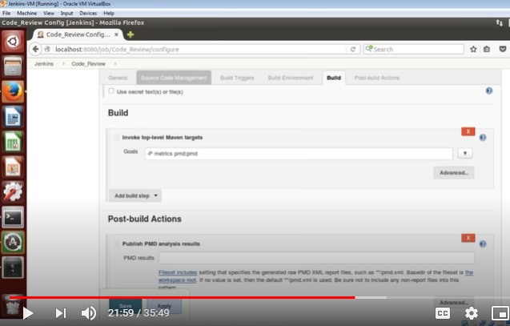

By following above process we will configure PMD profile to review the code

Now we are going to Run the Review Build

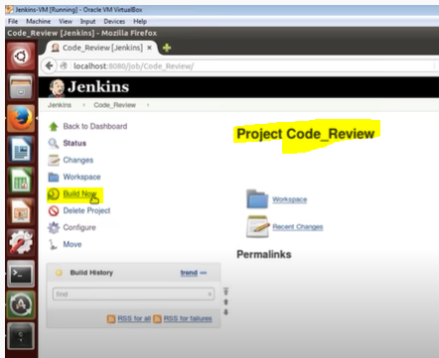

We can see the Review output once done by clicking PMD Warnings

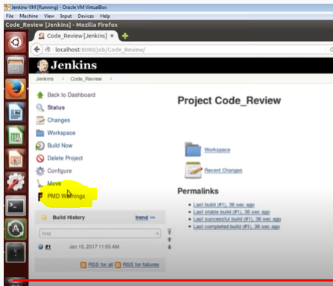

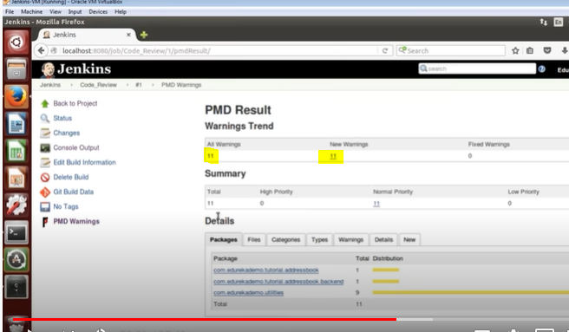

Above we can see the warnings

**Now we are going to configure Unit Testing Process**

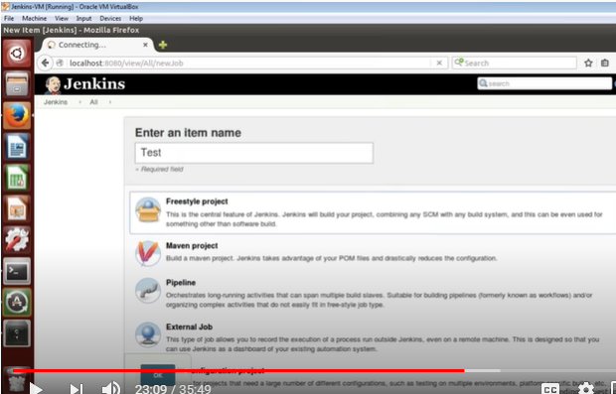

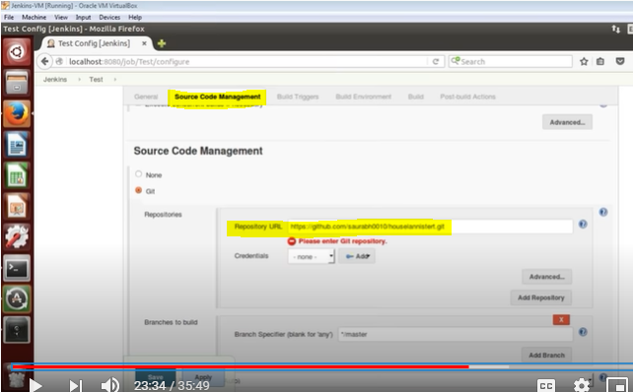

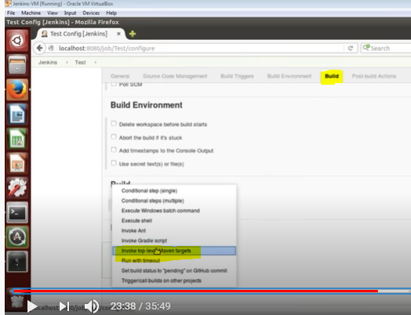

Already we know that Maven Build lifecycle have multiple build faces (validate ,compile,package,Test, Deploy)

So here we will use Test lifecycle in Goal’s

Some Test cases will place in Repository , by using those Unit Testing will happen.

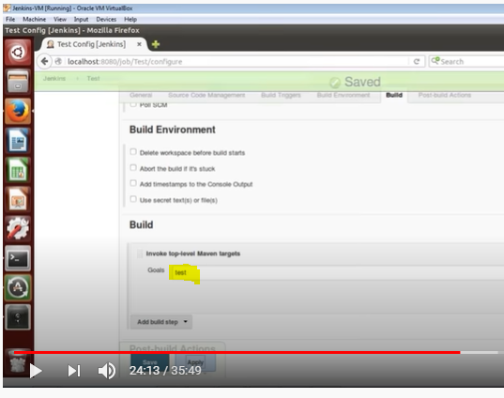

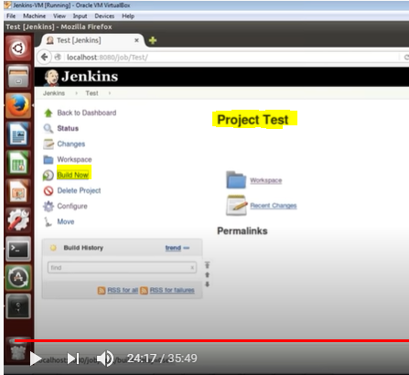

Now we are running those Test cases by running Build Now

By following above process we have compile the code , Review it and Test the functionality by using Test cases(Testing) completed

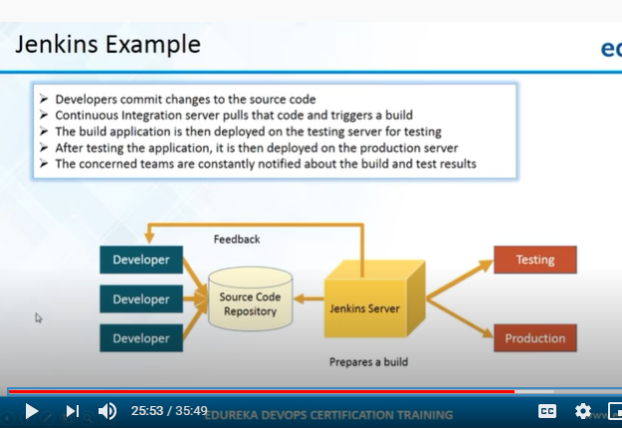

**Build Pipeline view- Now we are going to create Build pipeline for our project**

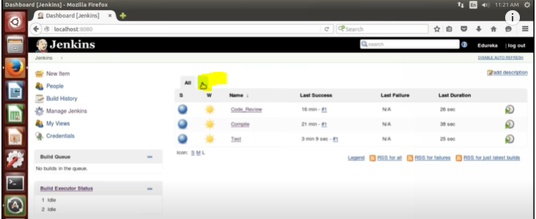

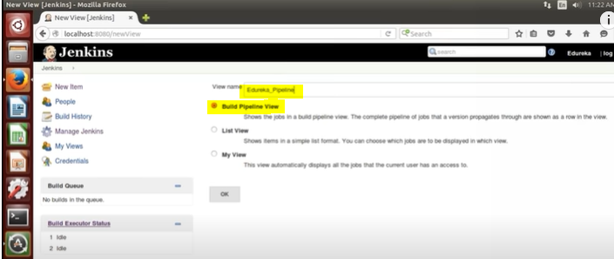

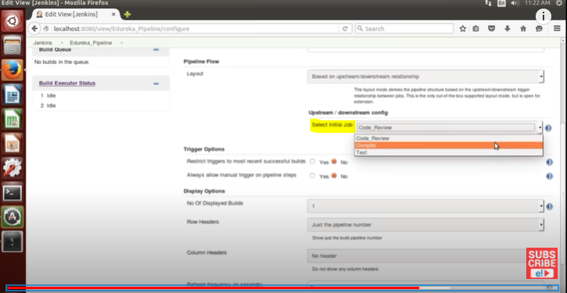

Above we have selected Initial Job(Compile)

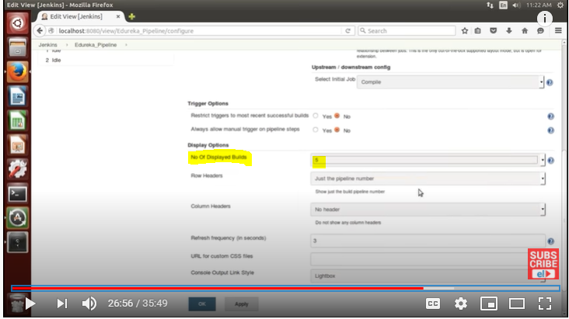

We have to select all the options as per our requirement

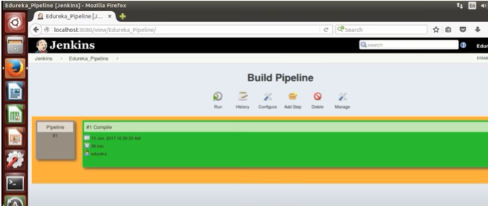

In Build pipeline only one job its created/configured , we can create multiple jobs as per our requirement.

By following below process we can add Jobs to existing pipeline

Go to Jenkins dashboard and open the job which we want to add to pipeline

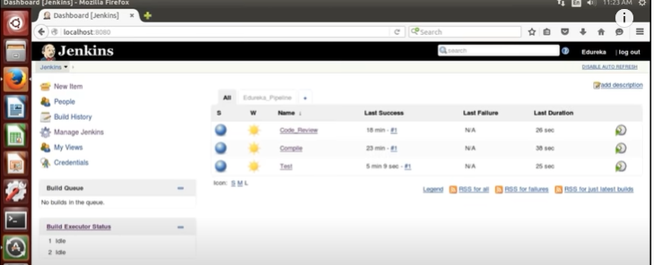

Select the Job and click on configure ,then go to build triggers option and provided/select required values like below

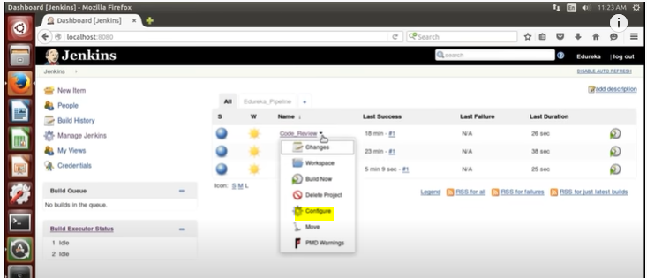

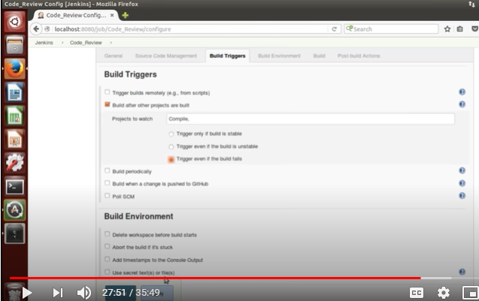

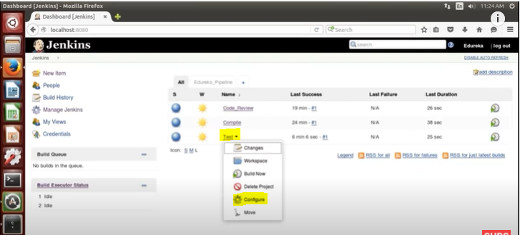

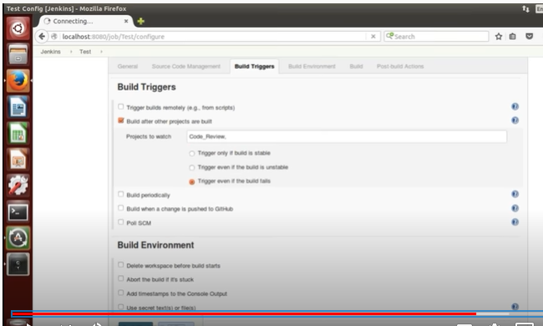

Below is the Build pipeline which we have created now we are going to Run it

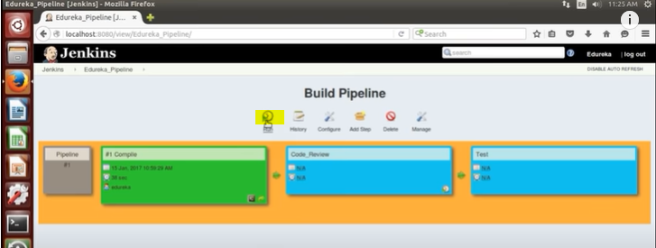

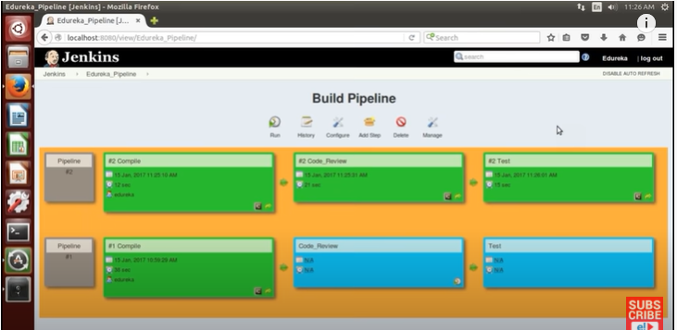

1st it compile the code once success it willReview it then Run the Test cases(Unit Testing)

We have some disadvantages if we use single Jenkins server

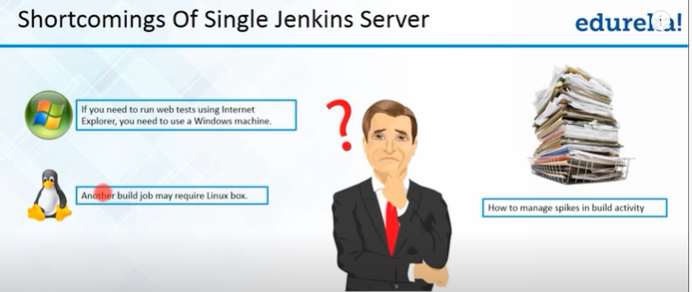

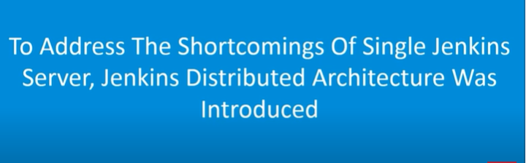

**Below is the Jenkins Architecture**

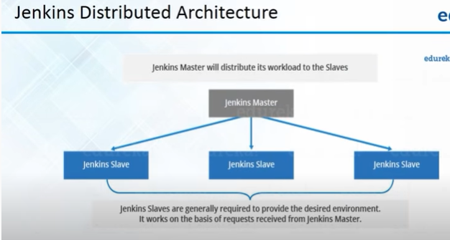

We will have only one **Jenkins Master** and **Multiple Jenkins Slave’s**

**Jenkins Master will Schedule the Build Job’s and it also dispatches Builds to Slave’s and it also Monitors the slaves status which or located in Remote (Off/On)**

**Slaves are nothing but Java executable of Remote machine**

**Jenkins slaves** will respond to Jenkins Master request and perform all the operations requested by **Jenkins Master**

Now we are going to create Jenkins Slave by following below process

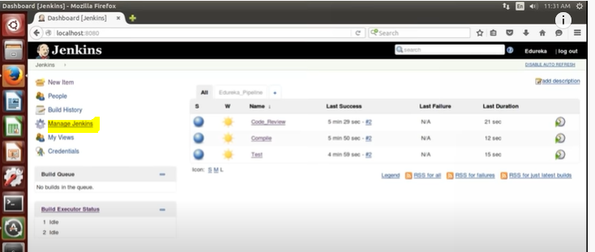

Click on Manage Jenkins , then select Manage Nodes

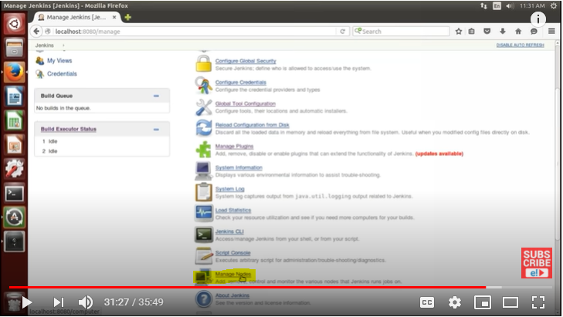

Then

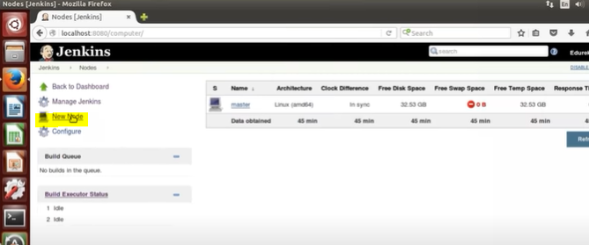

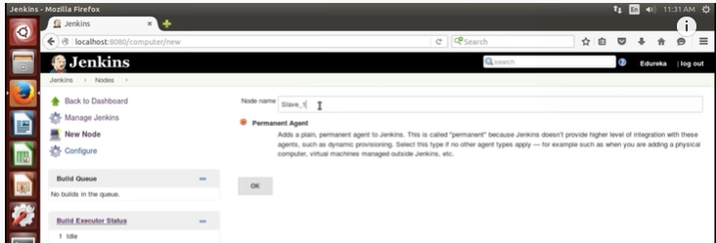

Jenkins slave name

Then have to provide few details to complete configuration

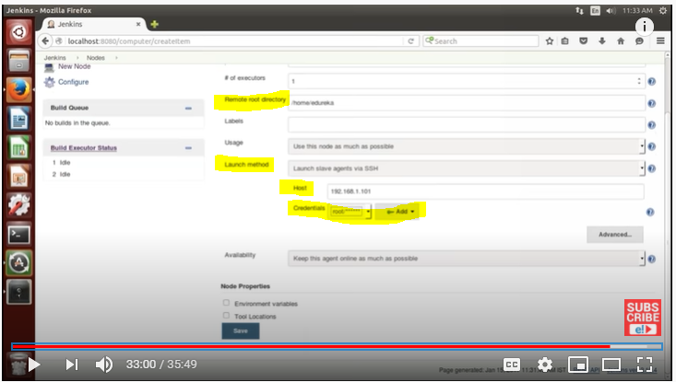

Above we have provided Root directory, Launch method, Host(Jenkins slave IP ), credentials and save it

Now Jenkins slave is created and available

By following above process we will create Jenkins slave and Added to Jenkins Master.

**Puppet,chef and Ansible are configuration Management tools**

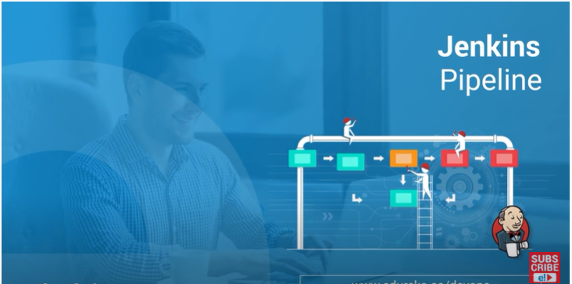

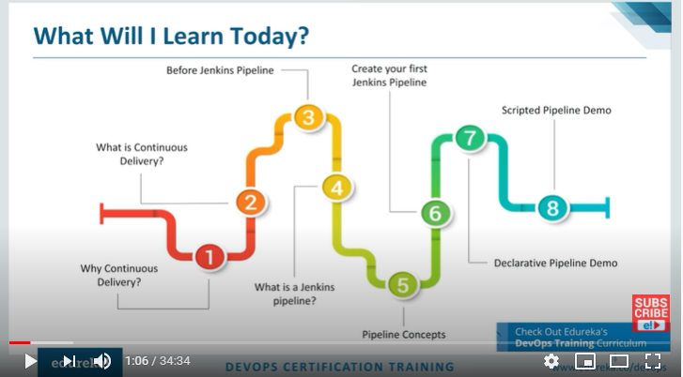

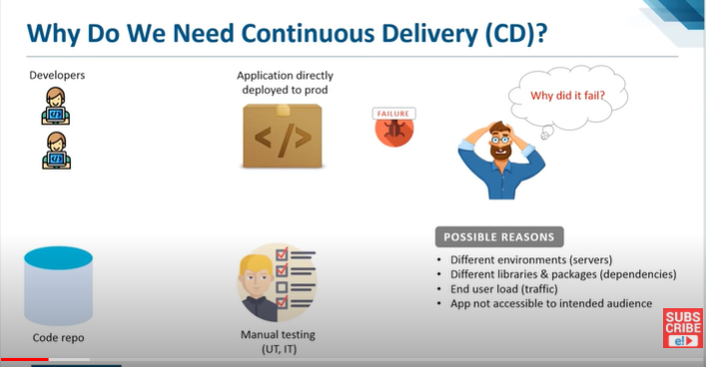

Continuous Delivery

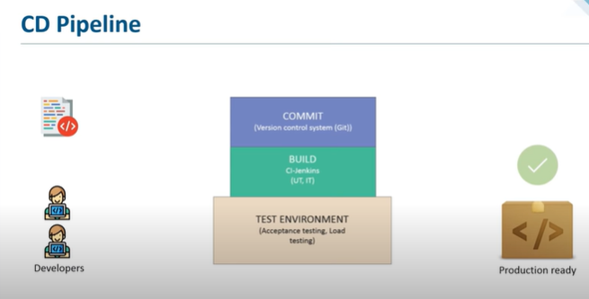

Developers will commit the code continuously in to repository , CI tool will monitor the repository continuously and if it found any new code in repository it will compile it and prepare the build and then deploy it on Non prod environment

Then now (UI and IT) testing will performed and if functionality is good then it will move to Prod Env

If they found any Bug they will report to Dev team.

**Version Control system(Git)**- It will maintain all the commit’s and it is very easy for developers to track the required commit

If any commit will effect our environment , it is very easy to revert it back

**Build:** we will use Jenkins for Build process

In Build process it will pull the changes from Repository and make a build of it and then deployed on Test Environment

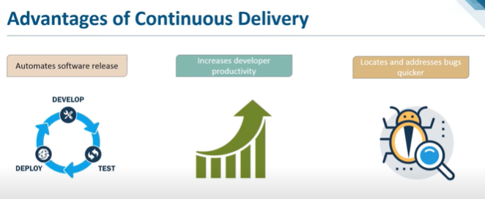

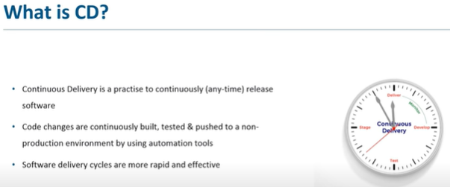

**Jenkins Pipeline**

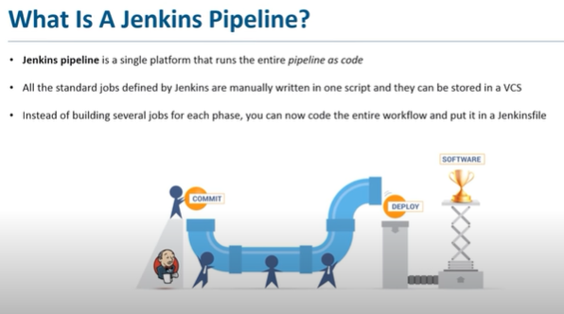

Before Jenkins pipeline Implemented we have **Build pipeline** where we will create multiple job’s by assigning process to them and chain them and will execute like below

It is good for small Architecture if we have 10jobs(process) we can go with Build pipeline process

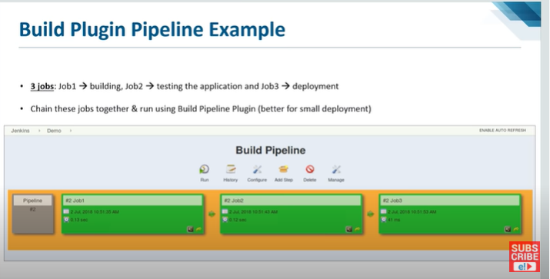

If it is complex pipeline its very hard to Implement them. If we have 100jobs its very hard to create 100jobs and make them as chain

We have some limitation for Build pipeline

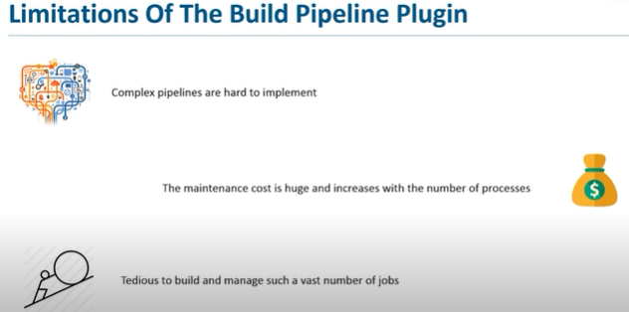

To overcome above Issue **Jenkins Pipeline** is introduced



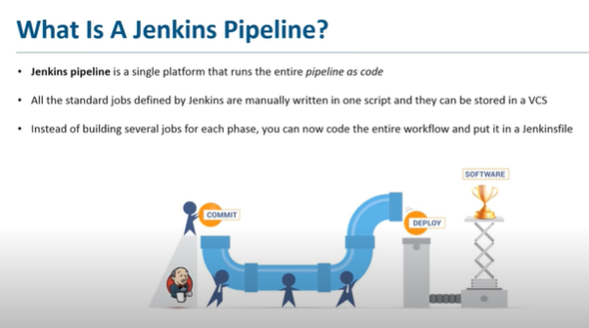

In Jenkins pipeline we can put/code Entire workflow as one text file(Jenkins file) in form of script and will store it in VCS

So that developers will access it any time if they want to edit any workflows

Jenkins pipeline is a single platform

Instead of created multiple jobs by assigning process and chain them , here in Jenkins Pipeline we will create one Jenkins file by mention all the jobs and will store in VCS

* We will code all the jobs and will Run in pipeline
* We will save Jenkins file in VCS

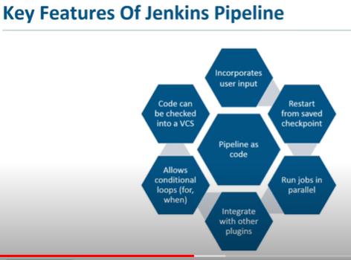



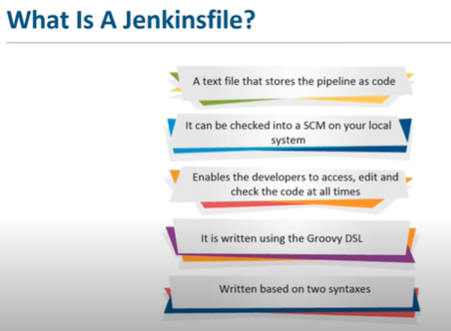

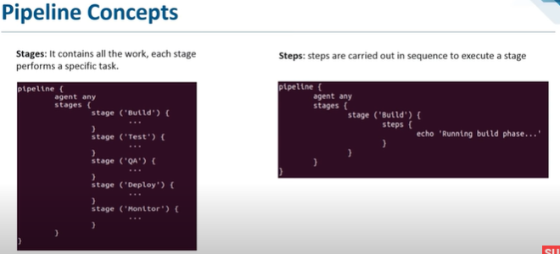

Now we are going to create Jenkins Pipeline

Logon to Jenkins dashboard, New Item, then Pipeline

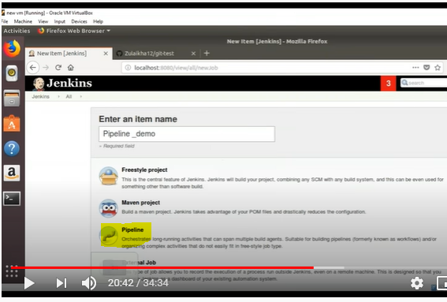

Below is the pipeline project configuration page , we have to move to pipeline configuration

Here we have two options which is highlighted below

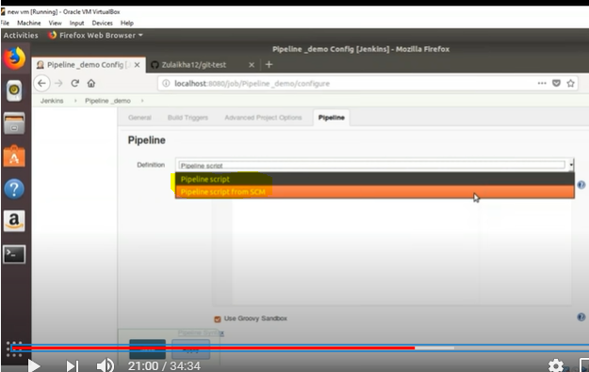

* Pipeline script- we will write our code/script in script window
* Pipeline script from SCM(source code Management)- Here we will access

**Pipeline script**

Here we will write code/script in script window like below

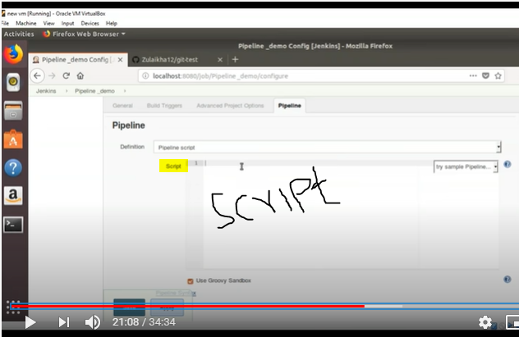

**Pipeline script from SCM**

Here we are access Jenkinsfile from SCM(Git)

Below we have selected Repository(Git)

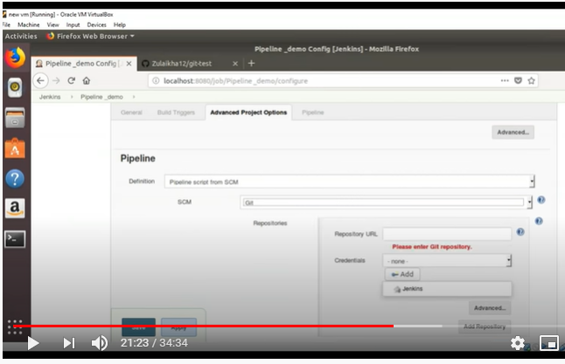

And now we have provided Repository url where jenkinsfile is placed (script/coded file)

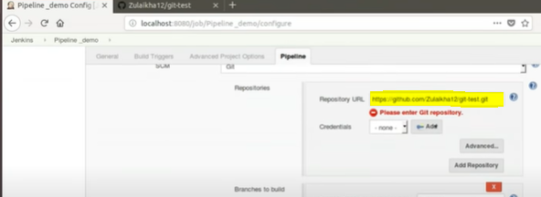

Above process is related to Jenkins pipeline.